

**MEDICINES AT YOUR FINGERTIPS**

## SY B.Tech. Minor Project Report

### SUBMITTED BY

### 

**Sumit Mahajan S208035**

**Vaishnavi Jadhav S204052**

**Praktan Khatavkar S208029**

**Mayur Pawar M**

**GUIDED BY**

**Prof. Sandeep Shiravale**

**SCHOOL OF COMPUTER ENGINEERING AND TECHNOLOGY MIT ACADEMY OF ENGINEERING, ALANDI (D), PUNE-412105 MAHARASHTRA (INDIA)**

**MAY, 2021**



**MEDICINES AT YOUR FINGERTIPS**

## SY B.Tech. Minor Project Report

*submitted in partial fulfilment of the requirements for the award of the degree*

*of*

### Bachelor of Technology

*in*

### COMPUTER ENGINEERING

**BY**

**Vaishnavi Jadhav, Praktan Khatavkar, Mayur Pawar, Sumit Mahajan**

**SCHOOL OF COMPUETR ENGINEERING & TECHNOLOGY**

**MIT ACADEMY OF ENGINEERING, ALANDI (D), PUNE-412105**

**MAHARASHTRA (INDIA) MAY, 2021**



**CERTIFICATE**

It is hereby certified that the work which is being presented in the SY B.Tech. Minor Project Report entitled **“*Answer Analysis System*”,** in partial fulfillment of the requirements for the award of the **Bachelor of Technology in Computer Engineering** and submitted to the **School of Computer Engineering and Technology of MIT Academy of Engineering, Alandi(D), Pune, Affiliated to Savitribai Phule Pune University (SPPU), Pune** is an authentic record of work carried out during an Academic Year 2020-2021, under the supervision of **Ms. Ashwini Mane , School of Computer Engineering and Technology.**

**Sumit Mahajan PRN : 0120190312 Seat.no : S208035**

**Vaishnavi Jadhav PRN : 0120190202 Seat.no : S204052**

**Praktan Khatavkar PRN : 0120190277 Seat.no: S208029**

**Mayur Pawar PRN : 0120190088 Seat.no:**

**Date:**

|  |  |
| --- | --- |
| *Signature of Project Advisor* | *Signature of Dean* |
| **Prof. Sandeep Shiravale** | **Mrs. Ranjana Badre** |
| School of Computer Engineering and Technology, | School of Computer Engineering and Technology, |
| MIT Academy of Engineering, Alandi(D), Pune | MIT Academy of Engineering, Alandi(D), Pune |

**(STAMP/SEAL)**

|  |  |
| --- | --- |
| *Signature of Internal examiner/s* | *Signature of External examiner/s* |
| *Name………………………………* | *Name………………………………* |
| *Affiliation…………………………* | *Affiliation…………………………* |

**ACKNOWLEDGEMENT**

We want to express our gratitude towards our respected project guide Ms. Ashwini Mane for her constant encouragement and valuable guidance during the completion of this project work. We also want to express our gratitude towards respected School Dean Mrs. Ranjana Badre for her continuous encouragement.

We would be failing in our duty if we do not thank all the other staff and faculty members for their experienced advice and evergreen co-operation

Vaishnavi Jadhav

Praktan Khatavkar

Mayur Pawar

Sumit Mahajan

## ABSTRACT

Medicines At Your Fingertips is a website aimed to provide all the information about any medicine, it’s side effects and all the other health related information. All the data of the medicines is stored in our database and it is fetched during the execution of user’s request. We have created the frontend using HTML, CSS, JS,JQUERY, JQUERY UI and Bootstrap. The Backend is built using Django Framework of Python. Our website contains 6 main components which are: MITIAN’s Chatbot: A intelligent chatbot which will give any information that the user has asked. The AI chatbot is created using the Pytorch library of python. It will also help the user to navigate from the whole website. Drugs A to Z, A drug dictionary to give all the information about the desired medicine. There are 2 ways to search the medicine. Pill Finder: To search the medicine alphabetically or using the search bar Phonetic Search: To search the medicine using voice command. Drugs By Condition: It contains the information about all types of health conditions, their causes and treatment along with some medicines which are used to treat them. Side Effects: It also has alphabetically sorted medicines which gives the information about the side effects of the particular medicine along with a search bar. First Aid: This part consists of 3 components which gives the information about first aid treatments and My Med List to set reminders for the doses of your medicine.

|  |  |  |
| --- | --- | --- |
|  | **LIST OF FIGURES** |  |
| **Fig. No.** | **Fig. Name** | **Page No.** |
| Fig 1 | Block diagram | 16 |
| Fig 2 | Use Case Diagram | 18 |
| Fig 3 | Sequence Diagram | 19 |
| Fig 4 | Activity Diagram | 20 |

## CONTENTS

|  |  |  |  |
| --- | --- | --- | --- |
| Acknowledgements | | | 4 |
| Abstract | | | 5 |
| List of Figures | | | 6 |
| 1. | Introduction | | 8 |
|  | 1.1 | Motivation for the project | 8 |
|  | 1.2 | Problem Statement | 8 |
|  | 1.3 | Objectives and Scope | 9 |
| 2. | Literature Survey | | 10 |
| 3. | Functional and non- functional requirements | | 12 |
| 4. | System Design | | 16 |
|  | 4.1 | Block diagram | 16 |
|  | 4.2 | Use Case Diagram | 18 |
|  | 4.3 | Sequence Diagram | 19 |
|  | 4.4 | Activity Diagram | 20 |
|  | 4.5 | Software requirements | 21 |
| 5. | Implementation Details | | 22 |
|  | 5.1 Algorithm and flowcharts | | 22 |
|  | 5.2 Results | | 23 |
| 6. | Conclusion | | 26 |
| References | | | 27 |

* 1. **INTRODUCTION**

In many cases the medical data is scattered on the internet and it is not easy to find the data user needs. That's why we have integrated all the medical data in our website so that one can find everything at one place. We are planning to build a user friendly website to provide the information and side effects of every medicine that a user wants to know with the help of our database. The website will contain all the useful information about various types of first aid treatments, skin infections and many more health related issues. With the help of this website user can also set reminders for the dose of medicines to be taken. We are also planning to integrate an AI chatbot which will guide the user through the website and it will also provide

any information user needs. And we will also integrate voice search for medicines in case the user cannot spell the drug correctly.

## Motivation

For this project, the main reason for our motivation was the inconvenience of the user while searching the information about a medicine. The user always have to go and search on google to get the information

about the health related issue. And in many cases it happens that the user is not able to find any information at all. So we decided to build a website which will have its own integrated data all at one place. It will

make it much more convenient for the user to find any information he wants only on our website.

## Problem Statement

To get medicine and its related side effects on tip of your fingers and also to combine First AID, Med list

and Drugs by condition this all over user requirement in one package with phonetic search, chatbot

and many more user-friendly objectives presence in MITIAN's DOCTOR WEBSITE.

## Objectives and Scope

1. MITIAN’S DOCTOR: A user-friendly chatbot that helps the user to get medicine info as well as

related side effects to it and also help the user to navigate through the overall website as per user command to it. This chatbot also provides extra help from various websites as per the need of the user. Various intents and with the help of neural networks can also conversate with a user.

1. DRUGS A-Z: Drugs at your fingertips helps the user to get all related information about specifically required medicine. This block is easy to go where operations can be handled by a 7-year-old child and can get his requirement fulfilled.
2. DRUGS BY CONDITION: Various topics have been covered in this topic where user can

Get static data of related condition and get a basic and needy solution for his ongoing condition.

Different types of a condition covered are Pregnancy Care, Wounds and Burns, Skin Infection and

many more.

1. SIDE EFFECTS: Side effects of various medicines can be obtained in this block for the user. This

block is easy to go where operations can be handled by the 7-year-old child and can get his requirement fulfilled.

1. FIRST AID: First AID mandatory requirement for all user can be obtained in this block. The overall functioning of every equipment and all requirements are covered in this block also first aid various situation has been covered in this block.
2. MY MED LIST: Med list creates a med list for the user where prescription given by the doctor can be saved in soft copy manner in this block and user can get necessary alerts for its prescription as per user requirement and get his work easy for handling doctor’s prescription.

# LITERATURE SURVEY

# FUNCTIONAL AND NON FUNCTIONAL REQUIREMENTS

### Functional Requirements:

* + 1. **Sign in:**

|  |  |
| --- | --- |
| **Purpose** | To Sign in using valid credentials. |
| **User** | Valid registered user. |
| **Input** | Username and Password |
| **Output** | Sign in successful.  Directed to Homepage. |

* + 1. **Sign up:**

|  |  |
| --- | --- |
| **Purpose** | Registration of new users. |
| **User** | Verified user. |
| **Input** | Details of users. |
| **Output** | Sign in page. |

* + 1. **MITIAN’s Doctor:**

|  |  |
| --- | --- |
| **Purpose** | To provide any information and navigate through website |
| **User** | Verified user |
| **Input** | A sentence |
| **Output** | A valid response to the query |

* + 1. **Pill Finder:**

|  |  |
| --- | --- |
| **Purpose** | To provide the information about any medicine |
| **User** | Verified user |
| **Input** | Medicine name |
| **Output** | HTML page containing the information about given medicine |

* + 1. **Phonetic Search:**

|  |  |
| --- | --- |
| **Purpose** | To provide the information using voice search |
| **User** | Verified user |
| **Input** | Voice command |
| **Output** | HTML page containing the information about the given medicine. |

* + 1. **Drugs by Condition :**

|  |  |
| --- | --- |
| **Purpose** | To give the information about various health condition |
| **User** | Verified user |
| **Input** | Name of the condition |
| **Output** | HTML page containing the information |

* + 1. **Side effects :**

|  |  |
| --- | --- |
| **Purpose** | To provide the side effect of any medicine |
| **User** | Verified user |
| **Input** | Name of the medicine |
| **Output** | HTML page containing the information about the side effects of a medicine |

* + 1. **First Aid:**

|  |  |
| --- | --- |
| **Purpose** | To give the information about the first aid treatments |
| **User** | Verified user |
| **Input** | Name of the incident |
| **Output** | HTML page containing the information about the first aid |

* + 1. **My med list :**

|  |  |
| --- | --- |
| **Purpose** | To set the reminder for the dosage |
| **User** | Verified user |
| **Input** | The quantity and time of doses |
| **Output** | The sorted schedule of the dosage |

* + 1. **Sign out:**

|  |  |
| --- | --- |
| **Purpose** | To sign out. |
| **User** | Verified user |
| **Input** | - |
| **Output** | Sign in page. |

**Non - Functional Requirements**

1. Performance requirements:

The system should support multiple users simultaneously. Every aspect or frame in business logic is handled in its best case which has reduced time complexity and thus increase in performance which helps user to navigate through various websites and can get results in less time span.

1. Design constraints:
2. To ensure that website is responsive and can be viewed in all
3. To ensure user data privacy.
4. Reliability:

The reliability of the overall program depends on the certainty of the separate components.

1. Accessibility:

The framework ought to be accessible consistently, which means the client can get to it utilizing an internet browser, just limited by the vacation of the worker on which the framework runs. In the event of an equipment disappointment or information base debasement, a substitution page will be appeared.

1. Security:
   * Passwords will be saved encrypted in the database so as to guarantee the client's security.
   * The user's IP will be logged.
   * Client data won't be shared to different clients.
2. Scalability:

website should able to adopt itself to increased usage or able to handle more data as time progress.

1. Responsiveness:

Website should be responsive to the user Input or to any external interrupt which is of highest priority and return back to same state.

# SYSTEM DESIGN

# Block Diagram

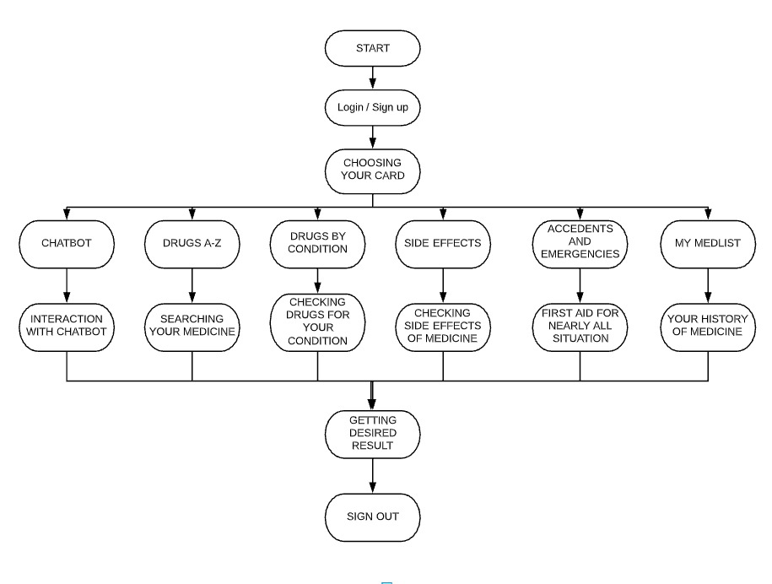

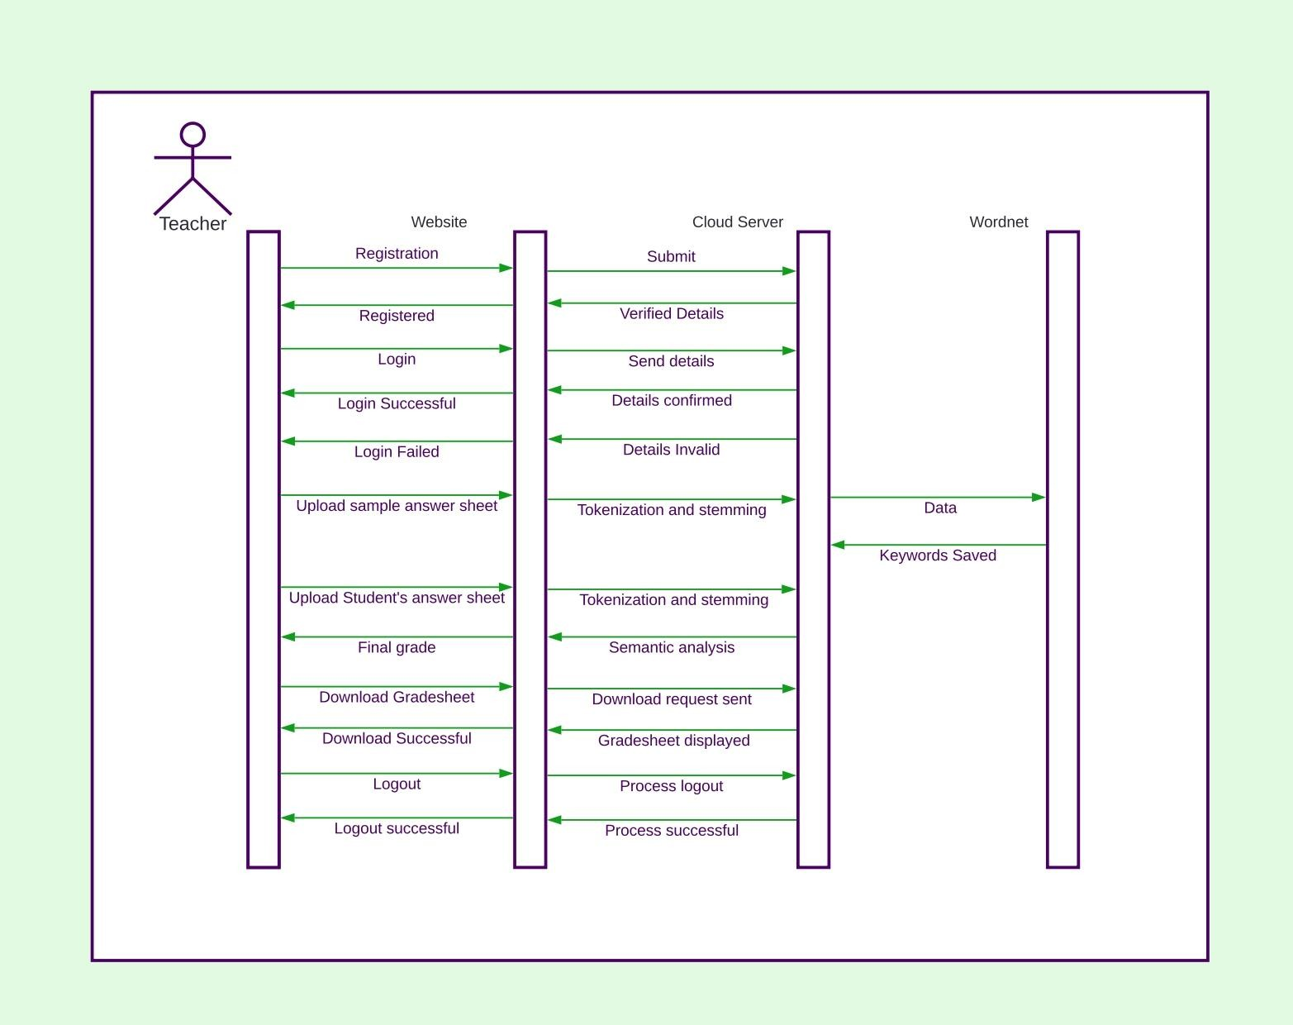

|  |
| --- |
| **4.3 Sequence Diagram**  App |
| Fig 3 |

* 1. **Activity Diagram**

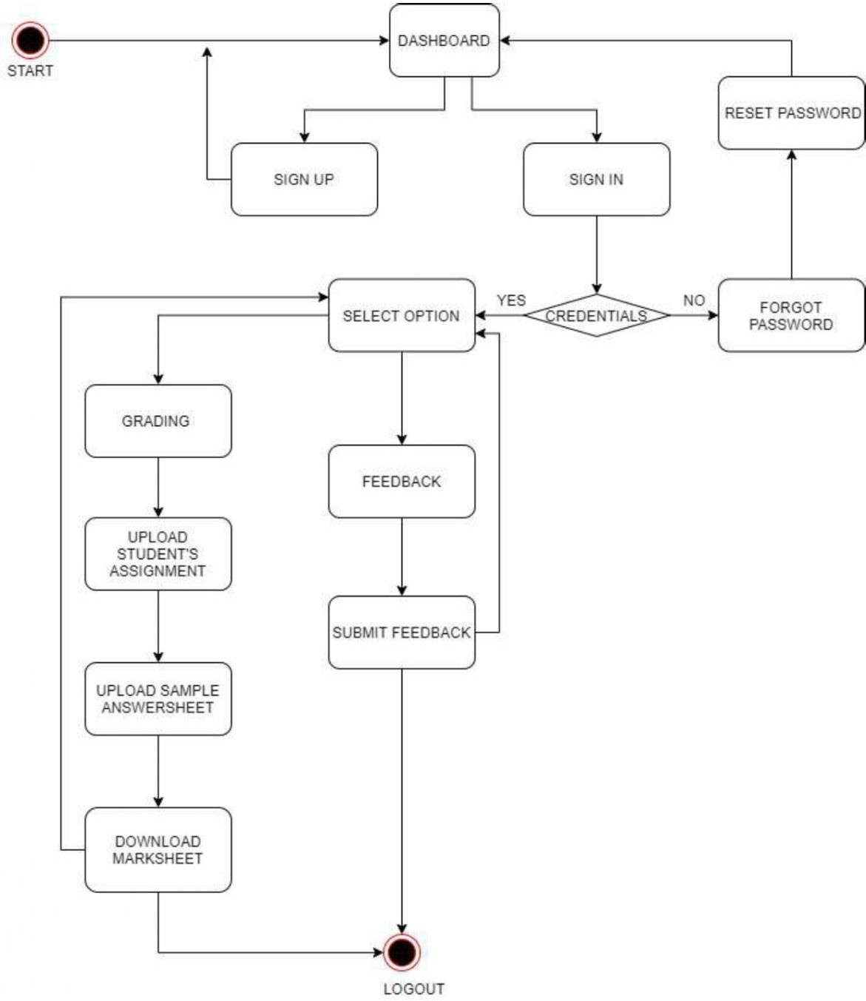

Fig 4

* 1. **Hardware and Software requirements**

1. Windows and Browser
2. External requirements : Internet Connectivity
3. **IMPLEMENTATION DETAILS**
   1. Algorithm for chatbot:

**STEP-1:** Tokenization: It is a way of separating a piece of text into smaller units called tokens [individual words].

**STEP-2:** Stemming process: it is the process of retrieving the derived words to their root or base words.

**STEP-3:.**Latent semantic analysis (LSA): it is used to check semantic similarity between 2 answers of students.

**STEP-4:** Bilingual evaluation understudy(BLEU): in this process sentences or statements written by students will be compared with a set of good quality references and the output will be calculated.

**STEP-5:**Fuzzy logic: it is used to combine the outputs of LSA and BLEU and grade the students accordingly.

**STEP-6:** The whole project is implemented using python programming language,

and wordnet: lexical database of English words. This evaluation system is very beneficial in the

educational field for analysing and grading subjective answers, hence reducing human work and giving more accurate and fast results.

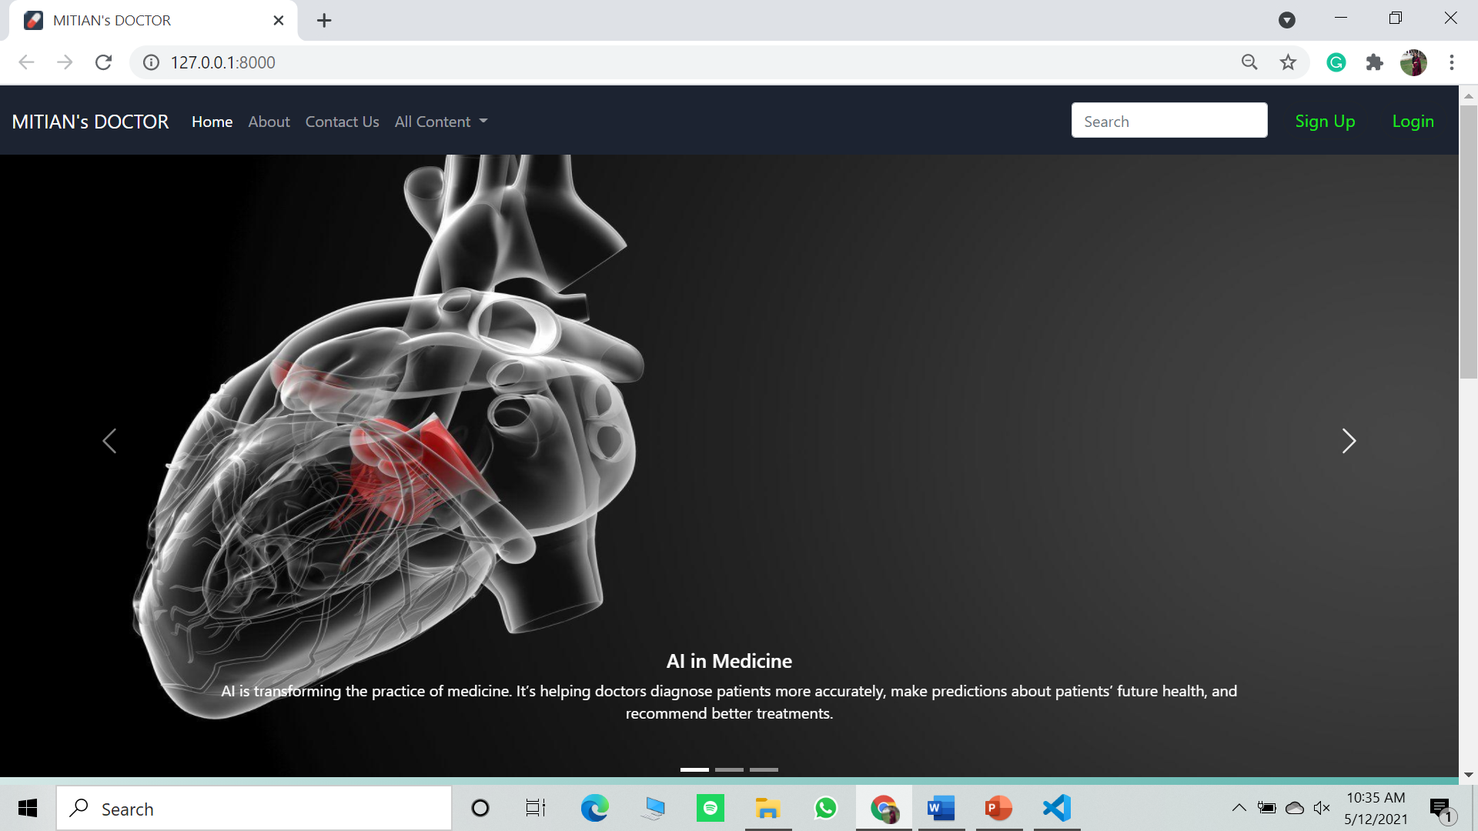Home Page:

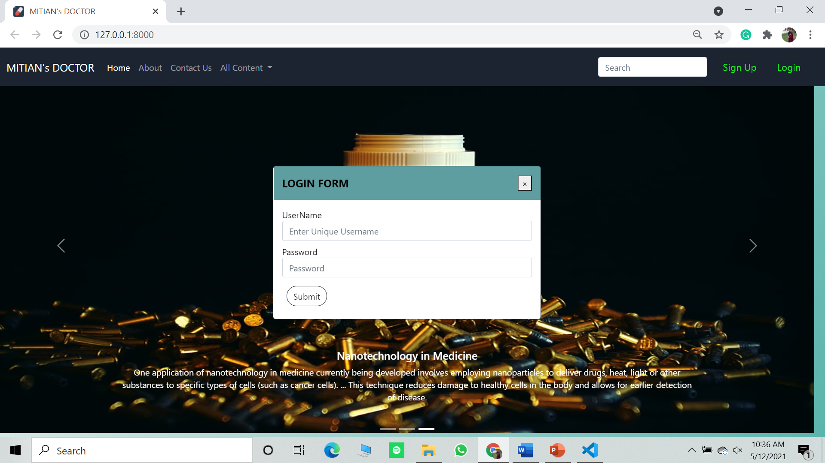Login:

Sign Up:

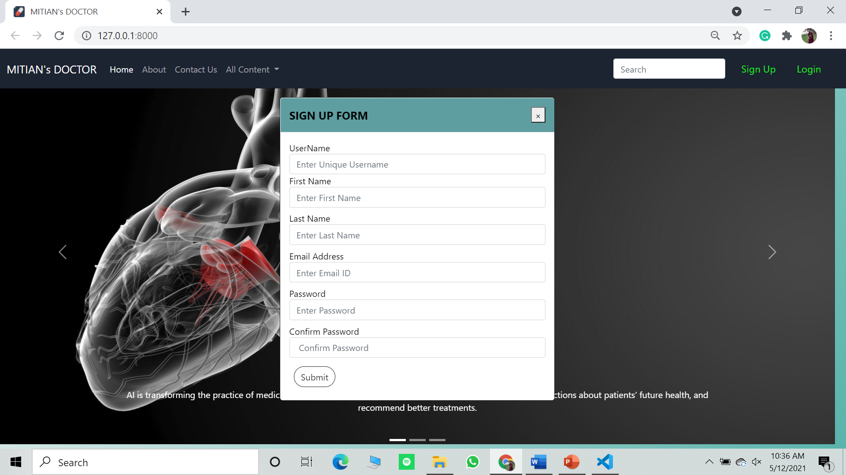

Contact Us:

# 

# 

# 

MITIAN’s Doctor (Chatbot):

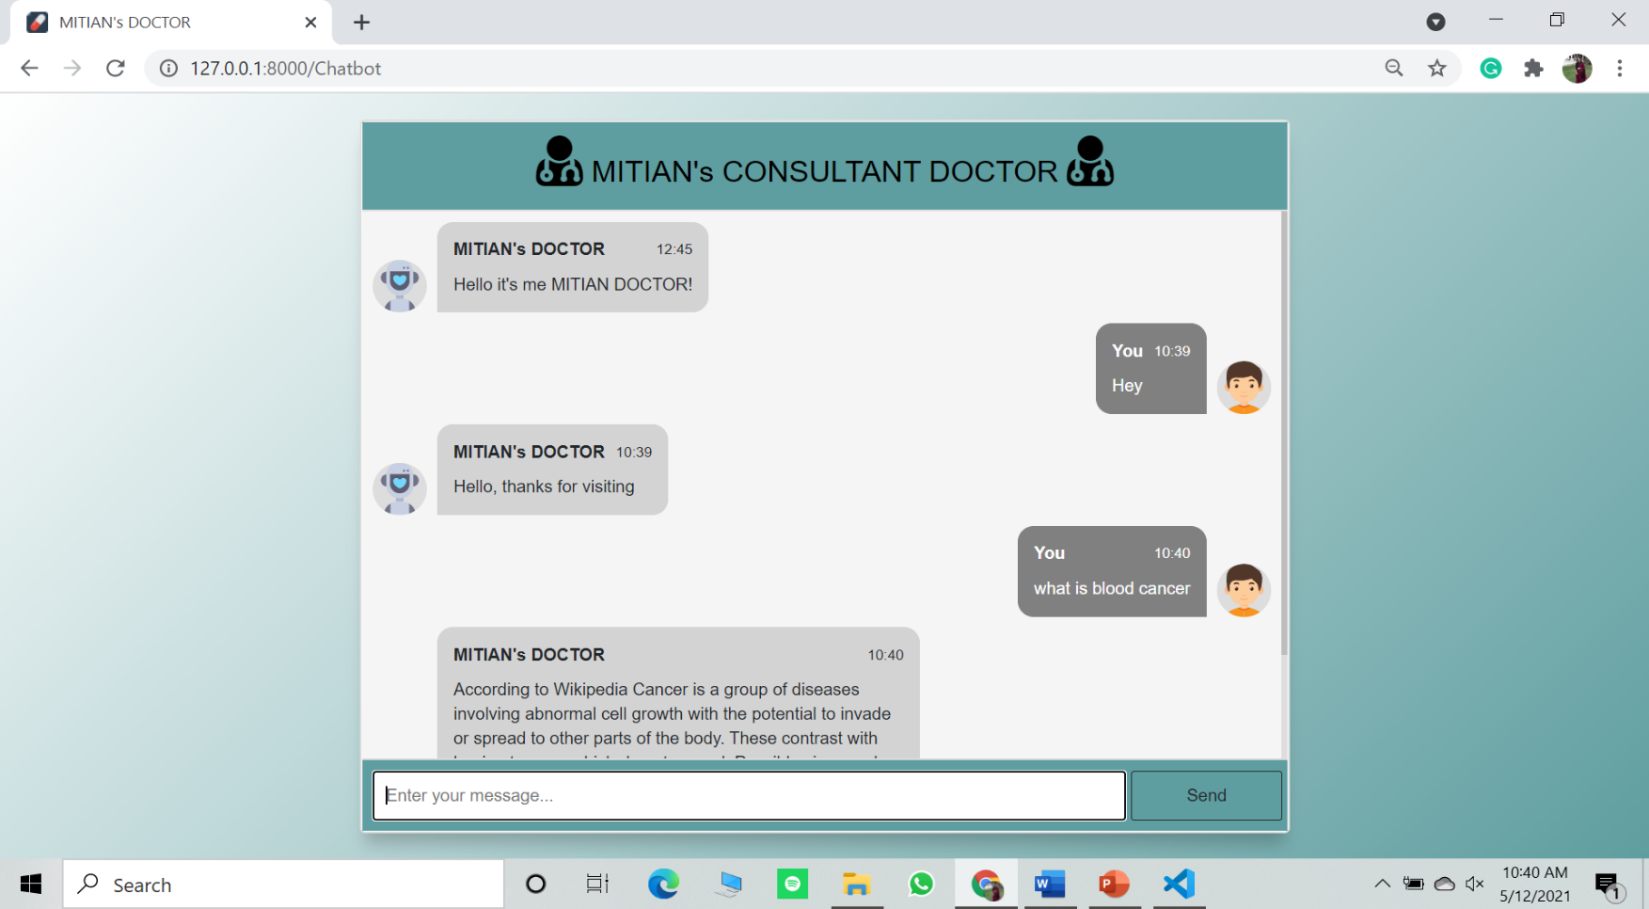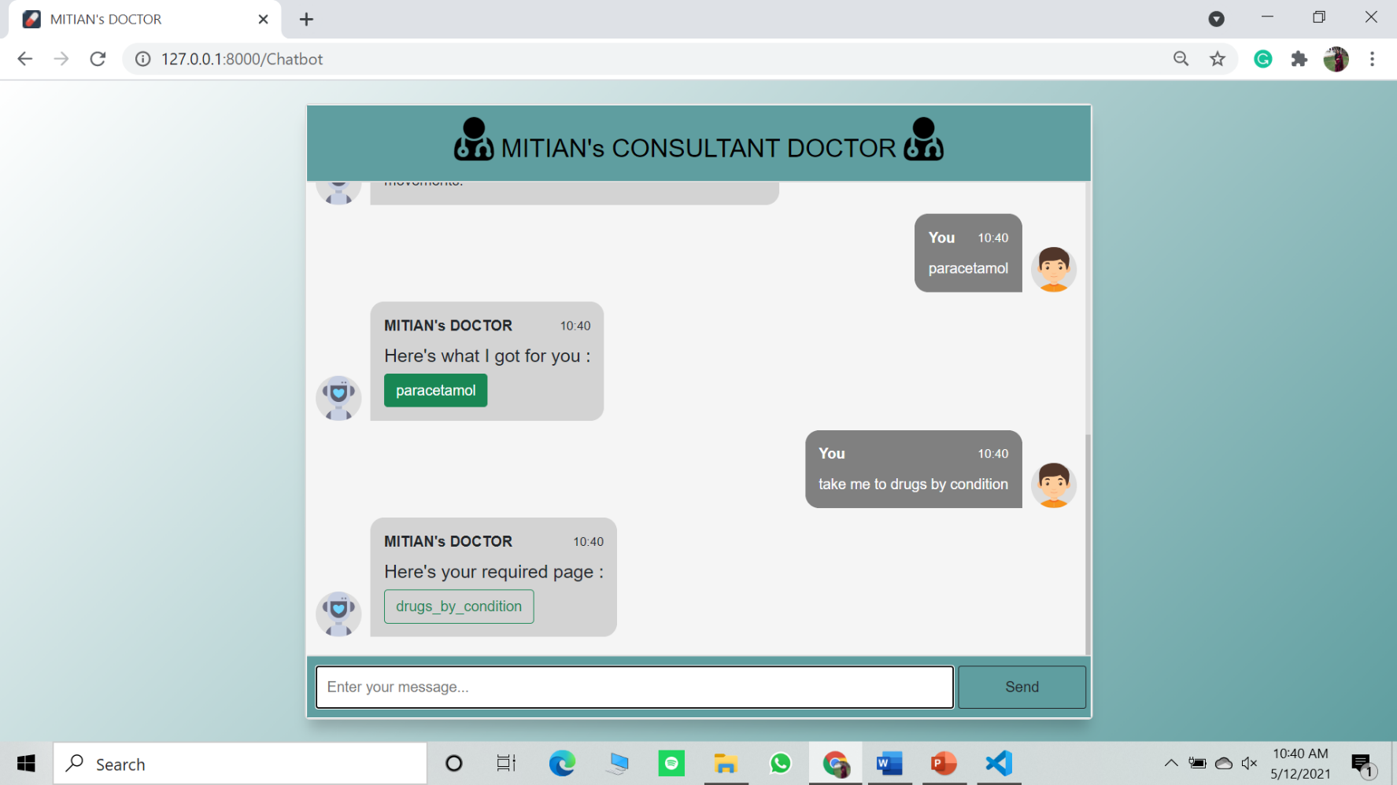

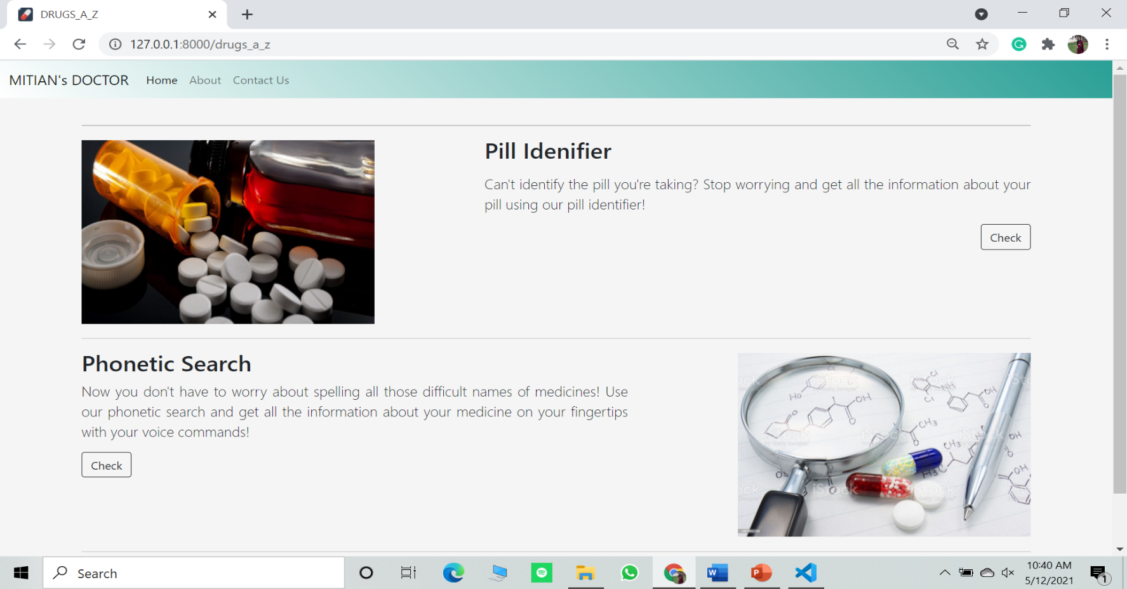Drugs A to Z :

Pill Identifier:

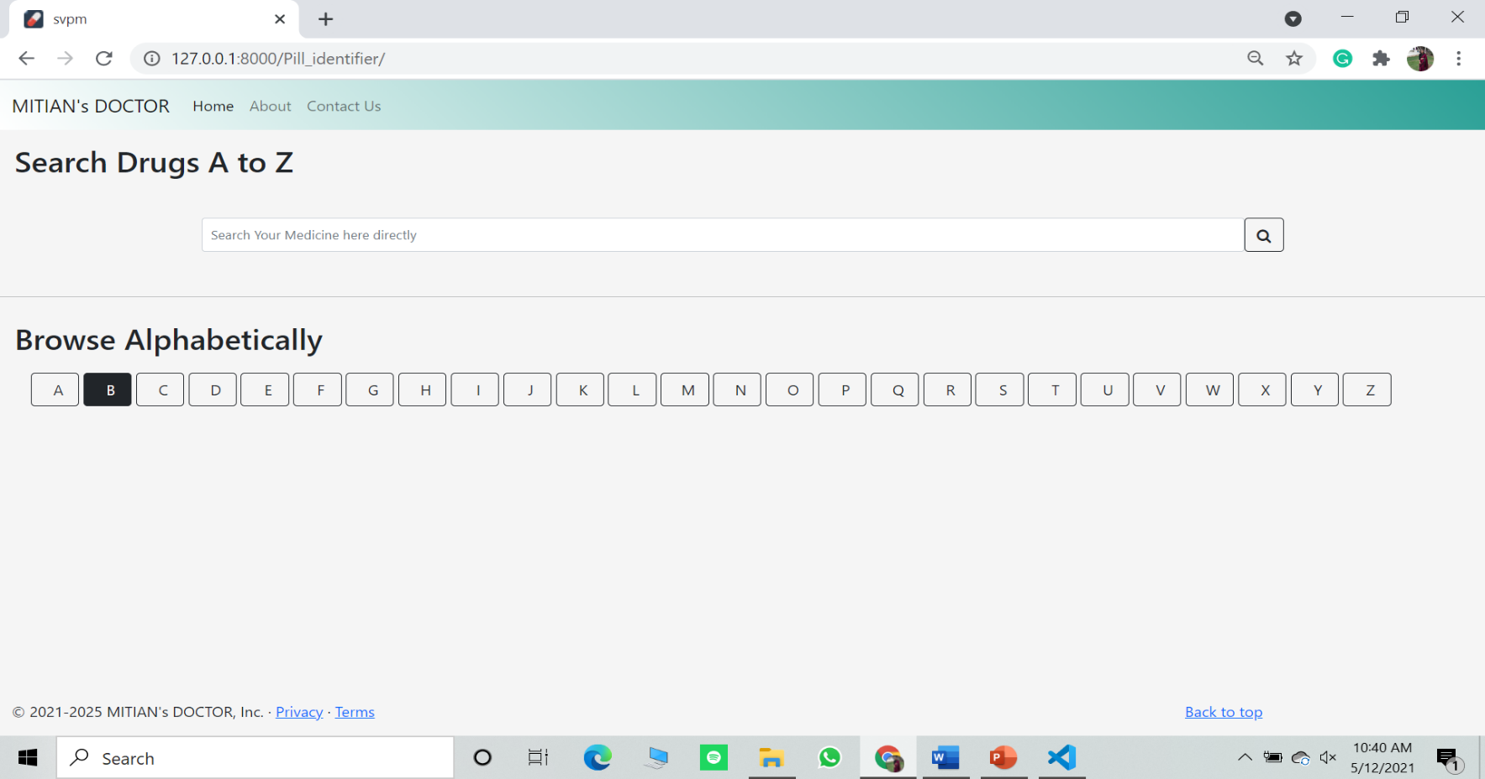

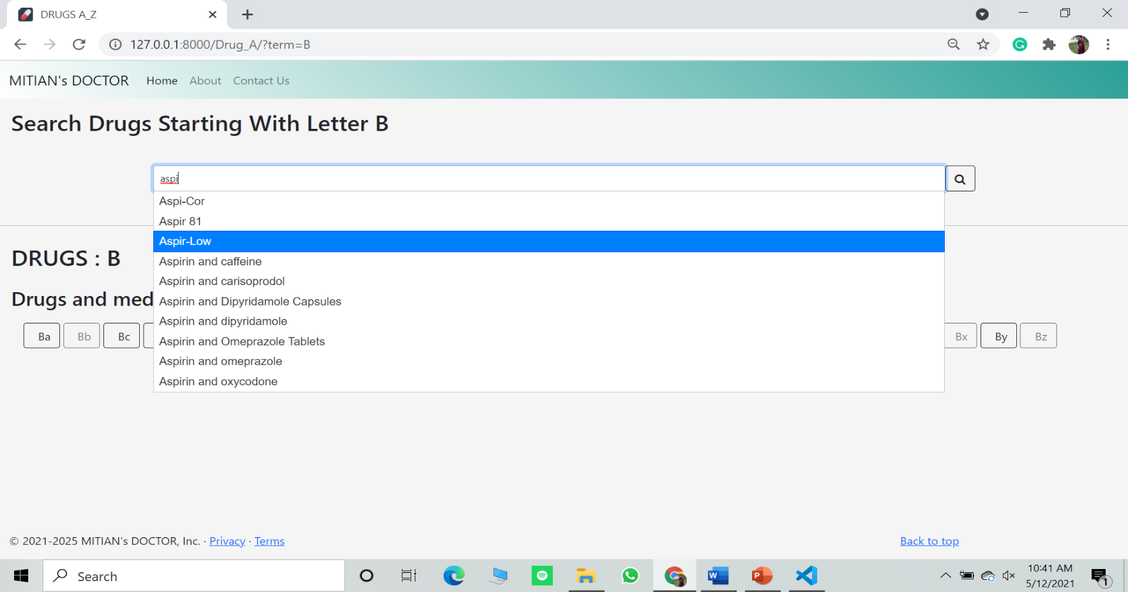

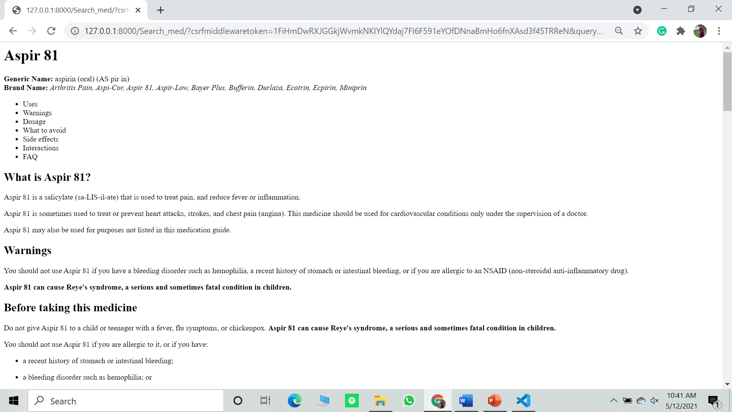

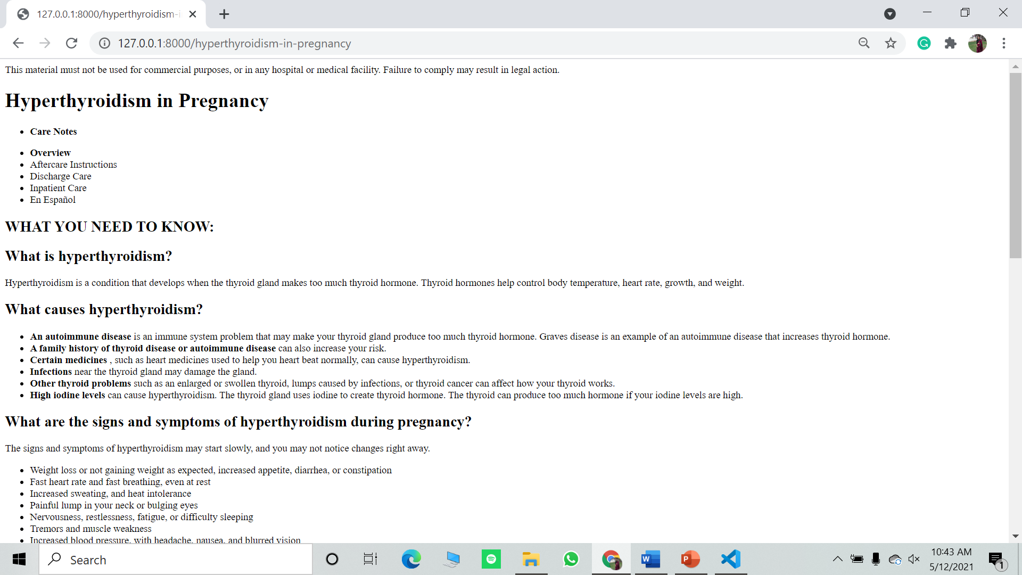

# CONCLUSION

The hybrid technique-based software can help to a large extent the human examiner in evaluating subjective answers in this COVID -19 pandemic. The techniques used for evaluation LSA and BLEU are complementary combination. The fuzzy function gives balanced weight to LSA and BLEU depending on different combinations of outputs. The use of WordNet helps in reduction of number of keywords to be given, as it finds synonyms of given keywords. This ensures student can make use of words of his choice.

Hence we conclude that our app is successfully created and it will work efficiently and provide accurate desired result along with benefit of reducing spread of virus which can spread through manual checking of answer sheets by teachers.

# REFERENCES

1. Y. Li, D. McLean, Z. A. Bandar, J. D. O’shea, and K. Crockett,“Sentence similarity based on semantic nets and corpus statistics,”IEEE transactions on knowledge and data engineering, vol. 18, no. 8,pp. 1138–1150, 2006.
2. Page, E. B., Computer Grading of Student Prose, Using Modern Concepts and Software, The Journal of Experimental Education, 62(2), 127–142, (1994).
3. Foltz, P. W., Laham, D., & Landauer, T. K. Automated Essay Scoring: Applications to Educational Technology. In B. Collis and R. Oliver (Eds.), Proceedings of EDMedia’99, Charlottesville, VA: Association of Computing in Education, (pp. 939–944), (1999).
4. Daina Perez, Aflio Gliozzo, Carlo Strapparava, Automatic Assessment of students free-text answers underpinned by a combination of a BLEU-inspired algorithm and Latent Semantic Analysis, American Association for Artificial Intelligence, (2005).
5. Attali, Y. and Burstein, J., Automated Essay Scoring with e-rater V.2, The Journal of Technology, Learning and Assessment 4(3), (2006).
6. Kakkonen, T., Myller, N., Sutinen, E., Timonen, J., Comparison of Dimension Reduction Methods for Automated Essay Grading, Educational Technology & Society, 11(3), 275–288, (2008).
7. Cutrone, L., Chang, M., Automarking: Automatic Assessment of Open Questions, 10th IEEE International Conference on Advanced Learning Technologies, IEEE, 143–147, (2010)